
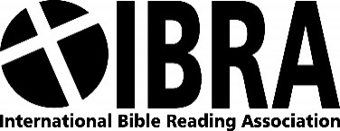

Gift Aid Declaration
Christian Education Movement
Please treat as Gift Aid donations all qualifying gifts of money made
Today in the past 4 years in the future
Please tick ALL boxes you wish to apply.
I am a UK taxpayer and understand that if I pay less Income Tax and/or Capital Gains Tax than the amount of Gift Aid claimed on all my donations in that tax year it is my responsibility to pay any difference.
Donor’s details
Title: First name:
Surname:
Full home address:

Postcode:

Date: Signature:

Please notify the Charity or CASC if you:
- Want to cancel this declaration
- Change your name or home address
- No longer pay sufficient tax on your income and/or capital gains
If you pay Income Tax at the higher or additional rate and want to receive the additional tax relief due to you, you must include all your Gift Aid donations on your Self-Assessment tax return or ask HM Revenue and Customs to adjust your tax code.
Return the completed form to;
Finance – IBRA, 5-6 Imperial Court, 12 Sovereign Road, Birmingham, B30 3FH

